PRESS KIT

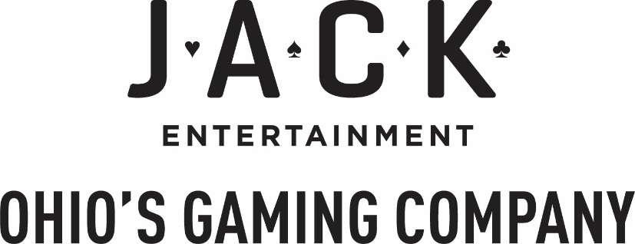

Fact Sheet

**Corporate Headquarters**

JACK Entertainment

100 Public Square

Cleveland, OH

44113

**About JACK Entertainment**

JACK Entertainment LLC is a Cleveland-based urban gaming company that owns and operates the gaming properties, JACK Cleveland Casino and JACK Thistledown Racino, the sports betting platform betJACK, and the 500,000 square foot Higbee Building featuring nine floors of office space. The JACK gaming portfolio includes over 1,400 team members, 14 bars and restaurants, and more than 1.5 million square feet of regional casino entertainment space, including more than 2,600 slot machines and video lottery terminals, 120 table games featuring blackjack, roulette, craps, baccarat, pai gow, poker, and two premium sportsbooks. Approximately 5 million guests visit JACK properties each year and generate over $500 million in revenue.

**Executive Management Team**

Chairman of the Board - Matt Cullen

Chief Executive Officer - Mark Dunkeson

Chief Operating Officer - Chad Barnhill

**Website**

[www.jackentertainment.com](http://www.jackentertainment.com)

**JACK Entertainment Entities**

**JACK CLEVELAND CASINO**

JACK Cleveland Casino opened May 14, 2012 as Ohio’s first full-service casino, located inside the historic Higbee Building in the heart of downtown Cleveland. Adding to the city’s impressive sports, entertainment, and cultural attractions, JACK Cleveland welcomes millions of guests to the casino each year. The $500 million gaming destination employs approximately 1,500 team members and features more than 1,200 slot machines, nearly 100 table games, a 28-table poker room, and a 6,000-square-foot sportsbook. The property has multiple bars, a buffet, two fast-casual food outlets, Nonna Pazza and Stack’d, and Starbucks. JACK Cleveland also has partnerships with a number of restaurants downtown and a preferred relationship with The Ritz-Carlton, Cleveland.

**JACK THISTELDOWN RACINO**

JACK Thistledown Racino opened on April 9, 2013 as a historic multi-faceted entertainment destination with 1,700 video lottery terminals, a two-story outdoor gaming patio, a 4,000-square-foot sportsbook, and live thoroughbred and simulcast racing. Nestled in the Cleveland suburb of North Randall, Ohio, JACK Thistledown’s food and beverage offerings include signature restaurant Millcreek Grille, Nonna Pazza pasta bar, OneKitchen Food Hall and The Bakery, Cleo’s sports bar, and two bars. Founded in 1925, JACK Thistledown is home to the Ohio Derby and is a mainstay on America’s thoroughbred horseracing circuit.

**betJACK**

betJACK is a licensed sports betting entertainment brand owned and operated by the Ohio-based gaming operator JACK Entertainment, which launched on January 1, 2023. betJACK offers real-money mobile and online operations, which have been designed explicitly for Ohio-based customers. The platform offers one-of-a-kind features, including Ohio-centric odds and promotions and The Locker Room, where players can find analytics and insights focused on their bets, earn trophies based on specific wagers, and customize challenges with friends. betJACK offers a free-to-play option that allows users to place wagers using tokens and explore the nuances of sports betting without using real money. betJACK has two physical sports books located in Northeast Ohio within JACK Entertainment’s two properties, JACK Cleveland Casino and JACK Thistledown Racino. For more information, visit betjack.com.