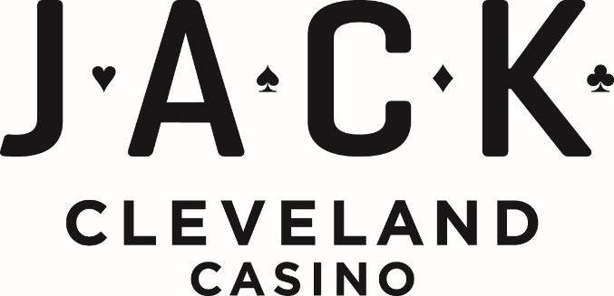

**Property Quick Facts**

**TIMELINE** 2012 – Opened as Caesar’s Horseshoe Casino, May 16, 2012

2016 – Transitioned to JACK Cleveland Casino under the JACK Entertainment Brand, May 12, 2016

**ADDRESS** 100 Public Square

Cleveland, OH 44113

**WEBSITE** [www.jackentertainment.com/cleveland/](http://www.jackentertainment.com/cleveland/)

**PHONE NUMBER** 216-297-4777

**SOCIAL MEDIA Facebook:**

[www.facebook.com/JackCleCasino](http://www.facebook.com/JackCleCasino)

**Instagram:**

[www.instagram.com/jackclecasino/](http://www.instagram.com/jackclecasino/)

**Twitter:**

www.twitter.com/jackclecasino

**MEDIA CONTACT** Public Relations

216-297-4899

media@jackentertainment.com

**SITE SPECIFICS** 300,000-square-foot casino located

in the historic Higbee Building, spanning

four floors

**CASINO** Over 99,750 square feet of gaming space

* Outdoor Gaming Patio
* Poker Room
* Sportsbook
* High Limit area

**RESTAURANTS**  Seven Chefs Buffet

American Burger Bar

STACK’D

Starbucks

**Bars/Lounges**

Vintage 51

Legends Bar

**HOTEL &**

**RESTAURANT PARTNERS** Preferred relationship with The Ritz-Carlton, Cleveland

Partnered with more than a dozen downtown restaurants to offer fine dining rewards to guests.

**PARKING** Valet parking

Two parking garages located on the corners of

Ontario and Prospect Ave

**JACK North Garage**

687 parking spaces

**JACK South Garage**

1,300 parking spaces



**CASINO**

**Fact Sheet**

**CASINO SPACE** JACK Cleveland Casino, housed in the historic Higbee building, once home to the famed Higbee Department store, was the first full-service casino in the state of Ohio. The casino is located in the center of downtown Cleveland, offering a unique urban gaming experience featuring over 99,7750 square feet of state-of-the-art gaming space.

**SLOTS** 1,200 reel and video slots, including the newest slots and traditional favorites, with denominations ranging from 1 cent to $500 per spin. This selection also includes a variety of video poker machines and electronic table games.

**TABLE GAMES** 88 table games including Blackjack, Commission Free Face Up Pai Gow, I Luv Suits, Craps, Crapless Craps, EZ Baccarat, Roulette, Ultimate Texas Hold’Em, Mississippi Stud Poker, Three Card Poker, and DJ Wild.

**HIGH-LIMIT GAMING** Located off the casino floor, the exclusive gaming area features 65 high-limit slot machines and 13 table games with additional private room room.

**REVEL OAK** 4,000-square-foot outdoor gaming patio immerses guests into the urban fabric of downtown Cleveland. Featuring wood accents, unique lighting, and elements of greenery, it is intelligently designed to keep guests comfortable during all seasons.

**POKER ROOM** 6,400-square-foot room offers 26 table games and dedicated amenities for players, including an exclusive lobby and reception area. Designed to create an unrivaled poker room experience, the space features a natural pallet of warm woods and light marble accented with vibrant blue hues offering an inviting environment.

**BETJACK SPORTSBOOK** Boasting a 35-foot video wall and an additional 14, 85’’ TV’s the 6,000 square-foot sportsbook offers the ultimate sports viewing experience. Five betting windows, 20 self-serve betting kiosks, and a 16’ odds board allow for convenient wagering. A variety of seating options include 45 theater-style recliners with phone chargers, 7 low-boy tables with swivel chairs, and 3 VIP banquettes. Dedicated gaming options are located within the sportsbook, including a 12-seat video poker bar, and a 9-game table game pit.

**CLUBJACK** JACK’s loyalty program offers a tiered program with six levels: J, A, C, K, and Infinity. ClubJACK gives the exclusive opportunity for guests to earn rewards while playing slots and tables to be redeemed for free play and comps with additional benefits, including gift giveaways and free parking.

**FOOD AND BEVERAGE**

**Fact Sheet**

**SEVEN CHEFS BUFFET** The 400-seat buffet offers seven unique stations for lunch, dinner, and weekend brunch. Seven specialty stations include Italian, American, Carving, Asian, Salad, Shuffle, and pastry. Rotating weekly menus include taco Tuesdays, BBQ night, surf and turf among others.

**AMERICAN BURGER BAR** Featuring all-American comfort food, this fast-casual restaurant located in the casino’s food court offers burgers, hotdogs, and wings. Open Sunday through Thursday, 11 a.m. to 3 a.m., and Friday through Saturday, 11 a.m. to 4 a.m.

**STACK’D** Offers gourmet sandwiches and pizzas made with fresh local ingredients. Located in the casino’s food court. Open Sunday through Thursday, 11 a.m. – 3 a.m., and Friday through Sunday, 11 a.m. to 4 a.m.

**STARBUCKS** Offering a full-service experience, guests can indulge in the many Starbucks items, from classic menu options to seasonal favorites, as well as the brand’s exclusive Nitro Cold Brew. The store is seven days a week, and for guest convenience, the store accepts Mobile orders and Starbucks Card Rewards.Open Sunday through Thursday, 7 a.m. – 9 p.m., and Friday through Saturday, 7 a.m. to 10 p.m.

**BARS AND LOUNGES**

**VINTAGE 51** Located on the casino’s second floor, the stylish retreat is tucked amongst the casino floor. Serving, craft beer, wine and cocktails**.** Open daily from 9:30 a.m. to 2 a.m.

**LEGENDS BAR** Steps away from the betJACK sportsbook and offering its own large screen, Legends Bar is the perfect place to grab a drink while watching the game. Open Sunday through Thursday, 11:30 a.m. to 1 a.m. and Friday and Saturday, 11:30 a.m. to 2 a.m.